Brooklyn torah gazette
For yom tov pesach 5782
Volume 6, Issue 30 (Whole Number 285) 15-22 Adar II 5782/ March 16-23, 2022

How Traditional
Are Matzo Balls?
The Unusual History of the Kneidel
By Rabbi Yehuda Shurpin

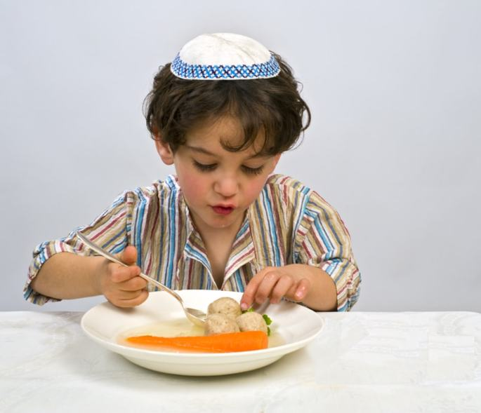

Matzah (or matzo) balls are basically soup dumplings made from matzo meal, eggs and other ingredients. Known in Yiddish as a kneidel, the matzo ball has become a staple in many Ashkenazic Jewish homes throughout the year but especially during the Passover holiday.
Interestingly, not only is there no mitzvah to eat matzo balls on Passover (or any other day of the year for that matter), some are actually careful not to eat them during most of Passover. But that itself may be one theory on the origins of the matzo ball.
Ok, let’s backtrack a bit.

History of the Kneidel
Although the exact origins of the matzo ball aren’t clear, it seems to be a relatively new invention dating back to sometime in the 19th century.
On Passover, it is forbidden to make anything that could become leaven or chametz. This of course precludes the adding of anything like a crouton, or something similar made out of flour, to a soup on Passover since that would be chametz. However, once a matzo was already properly baked then it can no longer become chametz.
The theory goes that at one point, perhaps when Eastern European cuisine began introducing dumplings in traditional foods, someone got the brilliant idea of using matzo crumbs, either from the leftover matzo after Passover or from the crumbs produced while baking matzo before Passover, to make “matzo meal” and produce the matzo ball. Nowadays, it is mass-produced by pulverizing matzos, which in most instances were specifically baked for this very purpose.
The kneidel gained fame in June 2013, when it was the winning word in the 86th Scripps National Spelling Bee. After the spelling bee, there was a debate as to the correct spelling.
But perhaps there is a deeper origin to the matzo ball, which we can glean from the fact that some are careful not to eat matzo balls for most of Passover.

Getting the Matzo Wet (Gebrokts)
Many communities, including Chabad, have the custom to refrain from eating gebrokts on the first seven days of Passover. Gebrokts is a Yiddish word that refers to matzo that has come in contact with water. It literally means “broken,” and it has come to mean “wet matzo” because matzo is usually ground or broken up into crumbs before it is mixed with water.
Those who refrain from eating gebrokts on Passover do so for fear that during the baking process there may have been a minute amount of flour that did not get kneaded properly into the dough. Upon contact with water, that flour would become chametz.
The custom of not eating gebrokts gained prominence around the end of the eighteenth century. At that time, people began to bake matzos much faster than halachically mandated, in order to be absolutely sure that the dough had no chance to rise before being baked. The flip side of this stringency is that the matzo we eat today is not as well kneaded as matzo used to be, and it is very possible that it contains pockets of flour (for more on this, see Was Matzah Always Hard and Thin?).

Holy Matzo Balls on the Eighth Day of Passover
However, most of these communities have the custom to specifically eat gebrokts on the eighth and final day of Passover (which only exists in the diaspora).¹
Why is this?
Passover celebrates the Exodus, a time when the Jewish nation was born. It represents a time when we are still spiritually immature, and we must be constantly on guard for the slightest bit of chametz (i.e., pride and ego), lest we be adversely affected. Fifty days after Passover, and after the seven weeks of character refinement we undergo with the Omer counting, we have spiritually matured and are immunized against the harmful side effects of “chametz.” We are then ready as a nation to receive the Torah. Thus, on the holiday of Shavuot, one of the communal offerings brought in the Temple was specifically made of chametz.²
By the last day of Passover, we’ve already completed the first of the seven weeks of the counting of the Omer. We are not quite ready for chametz, but we are a bit more refined and secure. For this reason, we eat our matzo with liquid, without fear of it becoming chametz.³
Another reason given is that the last day of Passover is connected with the future redemption (as can also be seen from the haftorah of the day), a time when no evil will befall us. We reflect this reality by going out of our way to eat gebrokts on this day, without fear that the matzo may become chametz.⁴
In light of this, many make a point to specifically have gebrokts on the eighth day of Passover. Of course, one of the best ways to do this is to have matzo balls in your soup on this day.⁵
So the next time you have matzo balls on the eighth day of Passover, don’t just think about the fine cuisine—remember that just as we were redeemed from Egypt, so will we merit the ultimate Redemption. May it be speedily in our days!

FOOTNOTES
1. Although the basic reason given for not being as strict about wet matzo on the eighth day is that this day is rabbinic in nature, this in and of itself doesn’t adequately explain the custom to specifically make a point to eat gebrokts on this day.
2. For more on this see Chametz: What Would Your Psychologist Say?
3. Talk by the Lubavitcher Rebbe, Acharon Shel Pesach 5727.
4. Talk by the Lubavitcher Rebbe, Acharon Shel Pesach 5744.
5. Those careful to only have gebrokts on the eighth day are particular not to make the matzo balls earlier until night has fallen on the final night of Passover (except when the final day of Passover coincides with Shabbat).

Reprinted from the Pesach 5781 email of Chabad.Org.com
Hard Truths about
Soft Matzah
By Carol Green Ungar

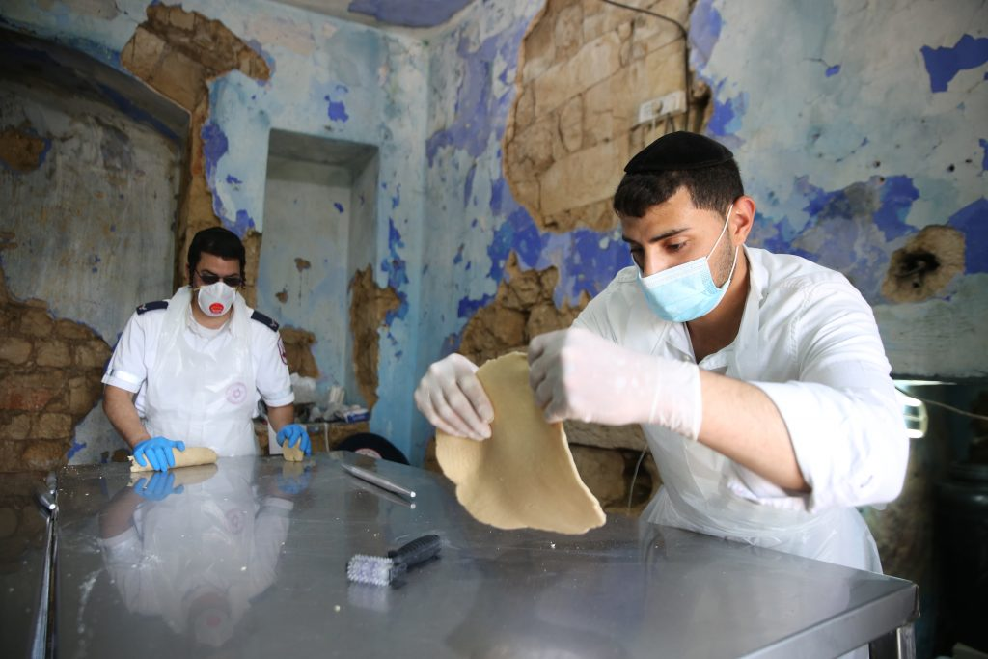
Yemenite Jews preparing matzot in Tzfat in April 2020. Photo: David Cohen/Flash90

What could possibly be new about matzah? Halachah lays out the recipe—flour, water and nothing else. No room for chocolate chips, chipotle or even pumpkin spice, and yet over the past few years a different kind of matzah has been turning up in the freezer section of kosher supermarkets: soft matzah. While such matzah is most certainly not new—it has old roots and continues to exist is some parts of the Sephardic world—in recent years it has become more commercially available.
Contemporary soft matzot are factory baked, wrapped in plastic and stored in the freezer. (These matzot must be defrosted immediately before being served.) But are they authentic matzot? To Ashkenazim, they look suspiciously similar to chametz flatbreads, such as laffa or pita.
Interestingly, these “new” soft matzot may be truer to tradition than their hard, more cracker-like brothers. Scholars claim that soft matzah was the “bread of affliction” eaten in Talmudic times and probably earlier. “There’s lots of textual proof that matzah in Talmudic times was softer and thicker,” says Rabbi Dr. Ari Z. Zivotofsky, a Jewish Action columnist who has co-authored several scholarly articles on this subject.¹ “Back then the matzot looked like pitot.” Supporting this claim, he cites a Talmudic discussion about confusing chametz and matzah. OU Rabbinic Coordinator Rabbi Avrohom Juravel also notes that the Shulchan Aruch refers to a matzah that is a “tefach thick,” which is about three or four inches thick.

Definite Advantages for the
Sephardim Who Use Soft Matzot
For Sephardim who use soft matzot for the Sedarim, there are certain advantages. Gone is the agony of rummaging through the box of shemurah matzah to hunt down three shleimim, unbroken matzot. Almost by definition, all soft matzot are shaleim, or whole; their softness obviates the possibility of breaking.
Soft matzot also make quick work of eating shiurim, the halachically mandated measurements that one must consume to perform the mitzvah of achilat matzah. While one might need as many as two-and-a-half pieces of handmade shemurah matzah to fulfill the Seder night requirements, one soft matzah might contain five or more kezayit measurements. “No need to stuff yourself,” says Rabbi Yosef Korkos of Boca Raton’s Maor David Sephardic Synagogue, which boasts the only matzah bakery in South Florida. The bakery produces Ashkenazic and Sephardic matzot. “Best of all,” he adds, “with soft matzah one may be able to eat korech, the famous Hillel matzah-and-maror sandwich, as a wrap, which was the way some posekim believe it is meant to be eaten.”²

No Question Concerning the Appropriate Blessing
Another benefit is that soft matzot are indisputably deserving of the Hamotzi blessing. As for hard cracker matzot (known in halachic parlance as rekikim), some Sephardic posekim, including Rabbi Ovadiah Yosef, maintain that they get the berachah of Mezonot. And not only Sephardic posekim maintain this position. The Tzitz Eliezer, Rabbi Eliezer Waldenberg, a well-respected twentieth-century Ashkenazi posek, debated whether Hamotzi should be recited over hard matzot, ultimately justifying the berachah on the grounds that the matzah forms the basis of the meal.³ (The debate over the blessing on matzah is relevant year- round, not just on Pesach.)
How do soft matzot achieve their soft texture? It’s all about the water. “Generally speaking, the less water, the harder and drier the matzah will be,” states Rabbi Avraham Manning in an online article.⁴ Rabbi Manning teaches in many educational institutions including the OU’s Seymour J. Abrams Jerusalem World Center.

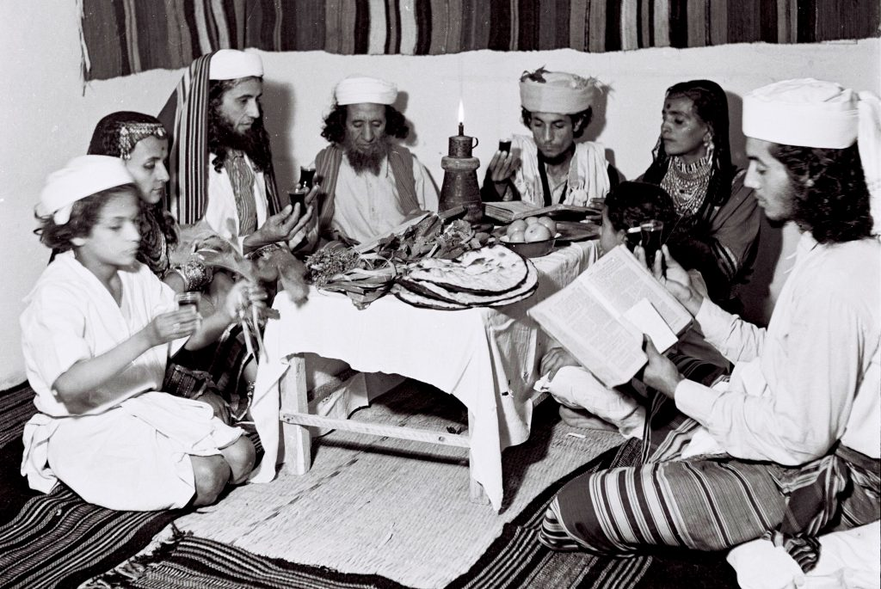
A Yemenite family celebrating the Pesach Seder at their new home in Tel Aviv in 1946. Photo: Zoltan Kluger/Israel Government Press Office

Soft matzah bakers routinely add more than twice the amount of water used in hard matzot, making the dough pliable, he explains. While the preparation of hard shemurah matzot requires skilled workers for rolling, riddling and placing the matzah in the oven, some of whom charge as much as $1,000 a day, soft matzot can be easier to knead and roll, although making them also requires a unique skill set.
At the Avoteinu bakery in Ashdod, Israel—the industry leader in soft matzah baking—the Yemenite hole-less soft matzot are formed inside a hot oven. “We have no tables or rolling pins. Just a bowl for hand-kneaded dough,” says Rabbi Shmuel Gerafy, CEO of the bakery. “Because the oven is hot (up to 842° F) our workers must move quickly or they’ll be burned.” It is still far lower than the oven heat used to bake Ashkenazi shemurah matzot, which can go up to 1300° F.

“This is cheaper and simpler,” says Rabbi Korkos. The difference is reflected in the price. Soft matzot generally sell for $30 a pound, while handmade Ashkenazi shemurah matzah can cost more. “You can get away with one matzah per person [to fulfill the mitzvah], as opposed to two-and-a-half pieces of hand shemurah,” says Rabbi Eli David, who sells soft matzah.
So, is soft matzah really new? Well, yes and no. In earlier centuries, matzot were usually baked at home in both the Sephardi and Ashkenazi world, often during Pesach. Furthermore, as stated previously, it seems that the matzot back then were thicker than the ones we use today.
Already hundreds of years ago, due to urbanization and other factors, matzah began to be produced well in advance of the holiday. Because of the long storage period, matzot were made thinner and drier so they would last. At the same time, some posekim also encouraged a thinner product fearing that thicker matzot might contain unbaked dough, which could turn to chametz.⁵ This is a serious halachic concern.

Ashkenazic Posekim Don’t Allow
Ashkenazim to Eat Soft Matzah During Pesach
“The thicker the matzah, the more likely the dough inside is not baked well,” explains Rabbi Juravel. “If water intermingles with the unbaked flour, the matzah becomes pure chametz.” Therefore, most Ashkenazic posekim are opposed to Ashkenazim consuming soft matzah on Pesach. “The only ones who can eat soft matzah are those Sephardim who have a mesorah on how to make it properly without it becoming chametz,” says Rabbi Juravel.
Generally speaking, Yemenite soft matzot don’t have holes. Rabbis Korkos punches holes into the soft matzot to prevent them from puffing up as that is a sign it may be becoming chametz. Rabbi Gerafy uses specially trained workers who form the soft matzot inside the oven and watch very closely to make sure they don’t puff up.
Yemenite Jews were among a small group of outlier communities where Jews continued baking matzot at home and during the holiday. This wasn’t always easy. Yom Tov Tzemah, a representative from the Alliance Israelite Universelle (a Paris-based international Jewish organization that protects the rights of Jews around the world), who visited Yemen in 1920, noted that while the soft matzot the Yemenites baked during the holiday were far tastier than the Ashkenazi cracker variety, the twice daily baking schedule was grueling for the bakers—most of them female. “What is the life of the women here, if not sadness and work?” he wrote.⁶
Is there a solution? Better flavor and less work? At the start of the twenty-first century, a new generation of Sephardic Jews started using refrigeration to revive the soft matzah tradition, while at the same time allowing the bakers to enjoy the holiday. They looked to the old-time home bakers. Rabbi Gerafy grew up with the tradition and learned how to bake soft matzah from his great-grandmother. And yet he and his family don’t bake during the holiday. At the Avoteinu bakery, baking starts around Chanukah, at the same time the Ashkenazi shemurah matzah factories start their work. Instead of wrapping the matzot in the familiar brown sheets of butcher paper, soft matzot are inserted into sealed plastic bags and then shrink-wrapped boxes, which are stored in freezers. In the US, soft matzah bakeries start production in Adar.

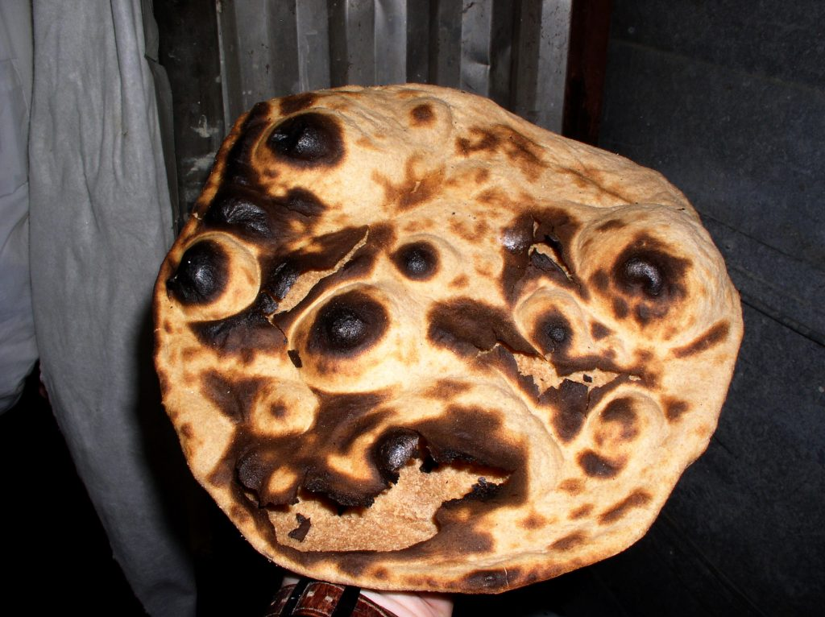
Yemenite soft matzah. Courtesy of Rabb Dr. Ari Z. Zivotofsky

All of those mentioned in this article who are involved in baking soft matzah have seen increased demand among Sephardi consumers. “Everybody likes them,” says Rabbi Korkos. “Last year was the first time we sold our matzot in stores. We sold 450 boxes, but we could have easily sold twice as many.” Rabbi David ships out thousands of pounds each year via Federal Express. “Interest increases from year to year,” says Rabbi Gerafy. When he began fifteen years ago, his annual sales hovered around 800 pounds. “Now we sell fifteen tons a year.”
The OU does not certify any soft matzah bakeries. “Former OU Kosher posek Rav Yisroel Belsky, zt”l, would not permit the OU to certify soft matzah,” explains OU Rabbinic Coordinator Rabbi Eli Gersten. “Although strictly speaking there is no halachah that forbids this, and there are Sephardim who have a tradition on how to bake them, the minhag of Ashkenazim is not to eat soft matzot.” Rabbanim also warn against home baking experiments—especially during Pesach. “It’s too easy to make a mistake and end up with actual chametz,” says Rabbi Gersten.
For those who are halachically permitted to consume them on Pesach, soft matzot are a tasty alternative to classic matzah boards. What about the rest of us? Enjoy them during the rest of the year—with or without chocolate chips.

Notes
1. See, for example, Rabbi Dr. Ari Z. Zivotofsky and Dr. Ari Greenspan, “The Halachic Acceptability of Soft Matzah,” Journal of Halacha and Contemporary Society (spring 2014), p. 108.
2. Not everyone agrees. According to some rabbis, korech is derived from the word “krach,” which means a walled city, implying a hard matzah covering the maror. See Rabbi Dr. Ari Z. Zivotofsky and Dr. Ari Greenspan, “The Thick and Thin of the History of Matzah,” Hakirah: The Flatbush Journal of Jewish Law and Thought 17 (spring 2014).
3. Rabbi Dr. Ari Z. Zivotofsky and Dr. Ari Greenspan, “The Halachic Acceptability of Soft Matzah,” Journal of Halacha and Contemporary Society, p. 116.
4. See Rabbi Avraham Manning, “Halachic and Hashkafic Issues in Contemporary Society,” https://www.ou.org/holidays/files/Halachic-and-Hashkafic-Issues-in-Contemporary-Society-OU-Israel-Center-Shiur-209-Soft-Matza.pdf.
5. Ibid.
6. Zivotofsky and Greenspan, “The Thick and Thin,” p. 121
Editor’s Note: Baking matzah (soft or hard) for Pesach use is a serious business. The resulting product will either be kosher for Passover matzah or it will be chametz (there is no middle ground). Consuming chametz on Pesach carries a prohibition of karet. Thus, unless one is an expert in the details of these halachot, it is best not to try it on one’s own.
Carol Ungar is an award-winning writer whose essays have appeared in Tablet, the Jerusalem Post, Ami Magazine, Jewish Action and other publications. She teaches memoir writing and is the author of several children’s books. Special thanks to Rabbi Dr. Ari Z. Zivotofsky, who helped with the preparation of this article.

Reprinted from the Spring 2022 edition of Jewish Action, the Magazine of the OU (Union or Orthodox)

A Teachable Moment for Ikarei Ha’Emunah
By Rabbi Herschel Schachter

Rabbi Hirsch Melech Shapiro (known for his sefer B’nai Yissoschor) writes a very fascinating idea in his sefer Derech Pekudecha. The Chumash records that Hakadosh Baruch Hu told Moshe Rabbeinu that He plans to bring about tremendous miracles in Mitzrayim in order that B’nai Yisroel should tell over these stories to their children and grandchildren so that they should know all about Hashem.
It would appear in the Chumash that the main purpose of the mitzvah of sippuryetzi’as Mitzrayim on Pesach night is to convey to our children all of the principles of faith (i’karei h a’emunah) which were demonstrated through all of the eser makos.
Although Hashem is invisible, after experiencing the eser makos first hand it became obvious and apparent that there is a G-d in the world. The Torah tells us also that Hashem caused all of the avodah zaras in Egypt to fall apart to demonstrate that there is only one G-d.
There were always thinkers who philosophized and suggested that it is physically impossible for the Infinite G-d to communicate with finite man; they claim there cannot be such a thing as prophecy. However, the people realized that Moshe Rabbeinu was a navi.
Included in the ikar ha’emunah of nevuah is the concept of tefillah. Just as G-d can, has, and will communicate with man, so too can man communicate with G-d by davening. The Torah says that B’nai Yisroel prayed and Hashem answered their prayers and took them out of Egypt. There were always thinkers who philosophized that although there is a G-d who created the world, because there is no such thing as spontaneous generation so there must have been a G-d who brought life into existence, but clearly after He created the world, He no longer pays attention to petty things that go on in this world and does not really follow with anything that goes on in this earth.

Pesach Proves that G-d Knows
What is Happening in this World
On the occasion of yetzi’as Mitzrayim it was clearly demonstrated that this is not so. The one and only G-d that created the world was fully aware of all that was happening. He punished the wicked and spared the righteous. The story of yetzi’as Mitzrayim demonstrated that there was clearly yedey’a (knowledge) of what was happening and also sechar v’onesh.
The entire Jewish nation heard both Moshe and Aharon deliver prophecies, but noticed that there was a stark difference between the two of them. Aharon’s prophecies were all regarding horo’as sha’ah while those of Mosher Rabbeinu were sometimes dinim l’doros and sometimes horo’as sha’ah.
The korban Pesach that was brought in Mitzrayim was a blend of dinim l’doros and horo’as sha’ah. When Hakadosh Baruch Hu instructed Moshe Rabbeinu to deliver the prophecy about the upcoming geulah, Moshe Rabbeinu says that when the people will ask me “what is His name, what should I answer”?

Hashem’s Very Cryptic Response
Hashem gives a very cryptic response and reveals to Moshe Rabbeinu another one of His seven names (zayin sheimos sh’einom nimchokim): Eh’k’ye Asher Eh’k’ye. Rashi, quoting from the Midrash, interprets the meaning of this name / statement to be that Hashem will be with the Jewish people until ge’ulas Mitzrayim will be completed, and Hashem promises that He will again be with the Jewish people in the future during the long galus to bring about the ge’ulah ha’asida.
Thus, the ikar of be’as ha’Moshiach was also revealed right before yetzi’as Mitzrayim. It is for that reason that on Pesach night, at the conclusion of the seder, we all recite Nishmas Kol Chai, asking for that day to come soon when all of mankind will recognize Hakadosh Baruch Hu as the one and only ruler of the world.
However, the Moshiach will only come when all of mankind is willing to accept the malchus of Hakadosh Baruch Hu. There are many hardcore atheists and ovdei avodah zarah who refuse to accept His malchus and because of whom the coming of Moshiach is being postponed.
It is for that reason that we pray to Hakadosh Baruch Hu right before the conclusion of the Hallel on the seder night, “Shfoch chamoscha…”, i.e. it is not fair that this group should hold back the coming of Moshiach. Wipe these people out and the rest of the nations of the world will be ready to accept your malchus.
All of these principles of faith of our religion could easily be explained even to young children on Pesach night. According to the simple reading of the pesukim, it would appear that that is the main purpose and should be the main theme of sippur yetzi’as Mitzrayim.

Reprinted from the Parshas Shemini edition of The Jewish Vues.

Who Authored the
Passover Haggadah?
By Yehuda Shurpin

The Passover Haggadah is one of the oldest and most widely published Jewish texts outside of Scripture (you can order or print the acclaimed Chabad.org Haggadah here). There is much discussion about the authorship of the Haggadah, which clearly evolved over time, starting from the Second Temple period through Mishnaic times, until its present form.
Parts of the Haggadah are recorded in the Mishnah, which was completed around the year 189 CE. There are additional parts that were added in the Talmudic era (which ended during the 5th century) and in the middle of the Geonic period (which lasted until the 11th century), and some of the songs were added much later.
The following is a very brief history of the Haggadah.

Cracked Roofs
The Torah commands us to retell the story of the Exodus to our children on Passover eve: “And you shall tell your children on that day…”¹ But as with other liturgy, there was no formal text until the time of the Anshei Knesset Hagedolah (“Men of the Great Assembly”), which flourished in the 4th century BCE.
What text was commonly used before the Anshei Knesset Hagedolah? The Mishnah² tells us that a core part of the Seder in Temple times was expounding upon the passage from Deuteronomy: “An Aramean tried to destroy my father…”³ These verses, which many were familiar with since they were said when the first fruits were brought to the Temple, describe our descent into the Egyptian exile and bondage and how G-d ultimately took us out and brought us to the Land of Israel.
A central part of our Haggadah quotes this text and provides rabbinic elucidation recorded in the Midrash Mechilta, which was composed by Rabbi Yishmael around 135 CE.
In Temple times, people would also sing the Hallel (Psalms 113-118), which was composed by King David.
As the Talmud describes it, they would often sit on the roofs of Jerusalem, praising G-d and singing the Hallel, to the point that the roofs would almost crack from the loud noise.⁴

Extra Question in the Mah Nishtanah
One of the Passover Seder highlights is the children asking the four questions. Interestingly, in the version of the Mah Nishtana found in the Mishnah, there is a question about the Paschal offering. The child asks why “on all other nights we eat meat roasted, broiled and cooked, [and] on this night [we eat] only roast.” Thus, the custom of the children asking the Mah Nishtanah harkens back to Temple times, when they would bring the Paschal offering to the Temple and eat the roasted meat. As commentaries point out, nowadays, we no longer ask this question, since this isn’t something that the child would see us do.
We also find other sections of the Haggadah text in the Mishnah. Some examples are:
“Rabbi Elazar ben Azarya (1st century CE) said: ‘I am approximately seventy years old . . . ,’ ” which is from the end of the very first chapter of the Mishnah.⁵
“Rabban Gamliel⁶ would say: ‘Anyone who did not say these three matters on Passover . . .’ ”
And the concluding statement before beginning the Hallel: “In each and every generation a person must view himself as though he left Egypt . . . therefore we are obligated to thank, praise, glorify, extol . . .”⁷
On the other hand, some sections record events that took place in Mishnaic times, but we only find them in the text of our Haggadah. An example of this would be the story “It happened that Rabbi Eliezer, Rabbi Yehoshua, Rabbi Elazar ben Azaryah, Rabbi Akiva and Rabbi Tarphon were reclining [at a Seder] in B'nei Berak . . . ”⁸
Two Beginnings of the Haggadah
While the Mishnah associates some specific texts with the Passover-eve proceedings, it appears that much was still left to the individual. For example, the Mishnah⁹ instructs us to “begin with disgrace and conclude with glory,” meaning that the arc of the narrative should begin with our sorry pre-Exodus state and end with the heights achieved after the Passover miracles.
But what are we to say? This was debated in the 2nd-3rd century by Rav and Shmuel (according to others, it was the Abaye and Rava in the 4th century).¹⁰
Rav held that the disgrace was a spiritual one. He thus promulgated a text that begins: Mitchilah ovdei avoda zarah, “At first our forefathers were idol worshippers . . . ,” and ends by recounting the glory of arriving at Sinai, where we received the Torah.
Shmuel held that the disgrace is that we were subjected and enslaved to the Egyptians. Thus, we begin with Avadim hayinu, “We were slaves to Pharoah in Egypt . . .”
The final law is in accordance with Shmuel (or Rava). We, therefore, start the Haggadah with Avadim hayinu. Since the disgrace is meant to be followed by its corresponding glory, we then read how G-d delivered us from Egyptian bondage.
In practice, however, we include both opinions in our Haggadah. So after talking about the disgrace of our bondage, we also say, Mitchilah ovdei avoda zarah, “At first our forefathers were idol worshippers,” and then recite its corresponding glory, which is about how we became closer to G-d.
Thus, according to Rabbi David Abudarham (fl. 1340), the text of our Haggadah is mostly a combination of these two versions.¹¹

The Siddur of Rav Amram Gaon
There were, however, some other additions during the Talmudic and Geonic periods.
The earliest text of the classic Haggadah, as it is recited to this very day, is found in the Siddur of Rav Amram Gaon (d. 875 CE). Incidentally, that is also the first version of the Siddur that we have in writing.
Several parts of the Haggadah first appear in this Siddur.
For example, the Aramaic declaration that is recited or sung at the beginning of the Seder, Hei Lachma Anya, "This is the bread of affliction," first appears in the Siddur of Rav Amram, leading many to conclude that it originates from the Geonic period. Others are of the opinion that it originated either in Israel or Babylonia in the 1st century after the destruction of the Temple. The Rebbe¹² points out that the fact that it is written in Aramaic is proof that it is from the period after the destruction, when the majority of Jews lived in Babylonia, for the rabbis would not have instituted an Aramaic text had they still been living in the Holy Land.
The classic Dayenu song also first appears in this work, which has led some to speculate that Rav Amram authored it. Others counter that based on the wording—especially the fact that it ends on the high note of the building of the Temple—it seems to have been authored earlier, perhaps during the Temple period.
Since then, there have been no real changes in the wording and scope of the Haggadah. At later times, especially in the Ashkenazi tradition, various piyyutim and songs were added to some versions of the Haggadah.¹³
The widespread custom is to conclude the Haggadah with the prayer L'Shana Haba'ah B'Yerushalayim, "Next year in Jerusalem"—meaning that by the following Passover, we hope to have already merited the final Redemption, when we will celebrate in the Holy Temple in Jerusalem.
May it be speedily in our days!

FOOTNOTES
1. Exodus 13:8. 2. Talmud, Pesachim 116a.
3. Deuteronomy 26:5-9. 4. See Talmud, Pesachim 85b.
5. Mishnah, Berachot 1:5. 6. This would appear to be a reference to Raban Gamliel I aka “the elder” who lived in the first century CE during temple times. Some, however, are of the opinion that it is a reference to his grandson, Rabban Gamliel II who was alive during the destruction of the Temple and was appointed nasi around the year 80 CE (see Rabbi Chaim Yosef Dovid Azulay in his Haggadah Simchas Haregel, ad loc).
7. Talmud, Pesachim 116a-b. 8. It should be noted that there is a somewhat similar story in the Tosefta (Pesachim 10:12) with Rabban Gamliel, but not the version that we all have.
9. Pesachim 10:4. 10. Talmud, Pesachim 116a.
11. Abudraham, Pirush Haggadah.
12. In his Haggadah, Haggadah Shel Pesach Im Likkutei Ta'amim Minhagim U'Biurim, Hei Lachma Anya. 13. For more on this, see Why Doesn’t the Chabad Haggadah Have the Post-Seder Songs? There are seven ‘songs’ that some append to the latter part or conclusion of the classic Haggadah as it appears in Rabbi Amram Gaon’s Haggadah. The seven songs are 1) Chasal Siddur Pesach Kehilchato, 2) Az Rov Nissim (some add the words Vayehi B'Chatzi Halayla at the beginning), 3) Ometz Gevuratecha, 4) Ki Lo Naeh, Ki Lo Yaeh - Adir B'Melucha, 5) Adir Hu Yivneh Beito Bikarov, 6) Echad Mi Yodeiya, 7) Chad Gadya.

Reprinted from the Pesach 5782 email of Chabad.Org Magazine.

How “Hard” was the Enslavement

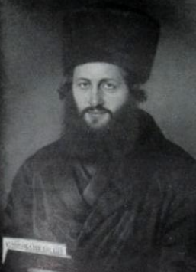

Hashem told Avraham that Bnei Yisrael would be enslaved in a foreign land for 400 years, but the exile in Egypt lasted only 210 years (and the enslavement, even less).
One popular explanation for how Hashem “justified” taking Bnei Yisrael out of Egypt after fewer than 400 years is that Bnei Yisrael were worked harder. But harder than what? asks R’ Avraham Shmuel Binyamin Sofer (the Ketav Sofer). There is no record that Hashem ever specified how hard the Jews would work during their enslavement. He answers: Hashem never told Avraham in what country the enslavement of his descendants would occur.
The mere fact that the enslavement occurred in Egypt made it more difficult for Bnei Yisrael than it would have been had it had occurred elsewhere. After all that Yosef had done for Egypt, the Egyptians’ turning against the Jews was more than Bnei Yisrael could bear. (Ketav Sofer, Parashat Bo)

Reprinted from the Pesach 5782 email of R’ Yedidye Hirteneld’s parsha sheet – whY I Matter for the Young Israel of Midwood in Brooklyn, NY.

